Sensor Calibration and Linear Regression

First experiment is intended to familiarize with some of the basics of the DAQ system. For many experiments in this course, you will be using a force sensor similar to the one shown in Fig. 1.1. This device is designed to output a voltage that is proportional to the force applied between the hook and the body of the sensor. The Dual-Range Force Sensor is a general-purpose sensor for measuring pushing and pulling forces. The BTA - British Telecom Analog connector cable allows your computer to read this voltage via the myDAQ interface. If Force Sensor is selected as the type of input, the myDAQ will assume it knows how to convert voltage to force and will simply read in units of force (N). However, to illustrate how the interface really works, we will not trust this conversion implicitly and will instead be looking at the raw voltage from the sensor.

The process of determining how voltage corresponds to force is an example of a process called calibration, and Experiment 1 walks you through a manual calibration procedure for this force sensor. This procedure is not the same as the Calibration feature of Vernier dual range force sensor, and the manual calibration described here will be far more accurate than that supplied by the manufacturer. Plastic deformations of the sensor components, changes in ambient conditions, and electrical offset sources may all change between experiments, so to increase the accuracy of your force measurements, you may consider checking the sensor calibration each week that it is used.
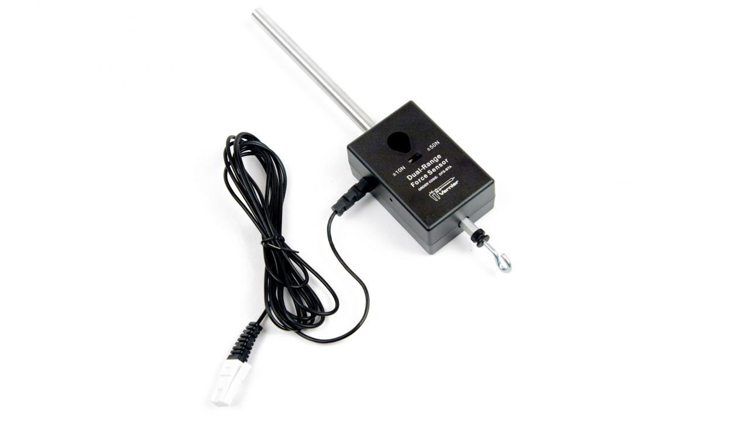
Fig 1.1: Dual Range Force Sensor

Objectives
- Analyze a relation between Voltage and Force of Force Sensor by calibrating
- Determine the uncertainties in the calibration.

Materials Required
- Computer System with LabVIEW & MS Office Excel Installed
- Force Sensor
- Slotted Mass (5 * 10gms) – 2 Sets
- NI myDAQ with Vernier myDAQ Adapter

Hardware & Software Setup
- First, attach the force sensor to a horizontal post or connect Rod to the sensor to hold it along so that the hook hangs vertically downward, appropriate for hanging weights from it.
- Open LabVIEW software for measuring change in voltage for a change in mass.
- To set up the force sensor to read its raw voltage, start your DAQ system using the instructions in Chapter 0 and connect Vernier myDAQ adapter to myDAQ device,
- In LabVIEW Program select Probe selection drop down to read voltage from LabVIEW software by choosing 0-5V Raw Voltage (Do not choose Force Sensor).
- On the Force sensor keep the range as +/- 10N by changing switch on Force sensor
- Run the LabVIEW Program.
- Note the reading of Single scaled value (Green Colored Back Ground) with no mass hanged to it.
- Usually sensor voltage varies from 0-5V where in with no mass hanged to it shows a value of 2.5V. that is 0 corresponds to 10V and 5V corresponds to -10V for a range of +/- 10V
- Hang weights and note corresponding values in Excel sheet as shown in figure – 1.2 Ranging from Masses 0 – 50 gms, Take minimum of 6 Samples.

Fig 1.2: Excel sheet showing fake data entered to explain process of calibration

- Tabulate the value at each mass while weighing as well as unweighing, take the average to get required Voltage.
- Usually Value in Single scaled value will be of 5 digits of precession, Note down corresponding values in excel with minimum of 3 digits of precision in excel sheet.
- As we use known masses we can directly calculate corresponding Force value from F=mg, where m is mass and g is 9.8m/s2.
- As Mass we use are in units of gms. Multiply it with factor of 0.001 to make it Kgs before performing F=mg.
- Thus formula will be F=m * 0.001 * 9.8 to calculate corresponding force for Sensor Voltage.
- Excel calculations will help you to automatically get corresponding values of Force from each mass by typing in “=A3*9.8.*0.001*” (Formula shown for figure 1.1 only) and drag the same to get corresponding values.
- Plot a scattered chart in excel by selecting Force and sensor voltage as shown in figure 1.1, follow Insert-> Chart -> scattered Chart
- Note that Voltage should be on X – axis and Force on y- axis.
- You can also enable axes titles and rename x and y axis details for the same to enhance the visual appearance.

Calculating Uncertainties in a Linear Fit with Excel
- For the chart plotted with data in excel, add Trendline from chart elements, double click on it to get trendline options and enable display equation on chart which is in the form of Y=mX + C. when we select curve as linear in trendline options
- Now go to Data in Excel and select Data Analysis ( If you cannot found it go to File - > Options -> Add-in and select Analysis Toolpak to be active )
- Click on Data analysis which is present in Data-> Data Analysis and select regression and click OK, a window will be opened as shown in below fig 1.3
Fig 1.3: Excel sheet showing Regression analysis

- Input Y range – Sensor Voltage and X Range - Force according to chart analysis.
- Enable Output Range and select any block on excel sheet and click OK
- Now you will get below report of uncertainties as shown in Fig 1.4

Fig 1.4: Excel sheet showing Uncertainties for fake values as on Fig 1.1.

- Uncertainities of equation Y=mX+C can be calculated by Standards errors in excel sheet as shown in fig 1.4.
- C is denoted by Intercept under coefficients, m denoted by X variables under coefficients.
- Uncertainty equations will be noted down on Lab record book/Documentation of Students.
Data Table

Mass in g | Voltage in V  (Weighing) | Voltage in V  (Unweighing) | Average Voltage in V | Force in N
0
10
20
30

Measurement of acceleration due to gravity

We say an object is in free fall when the only force acting on it is the Earth’s gravitational force. No other forces can be acting; in particular, air resistance must be either absent or so small as to be ignored. When the object in free fall is near the surface of the earth, the gravitational force on it is nearly constant. As a result, an object in free fall accelerates downward at a constant rate.

Physics students measure the acceleration due to gravity using a wide variety of timing methods. In this experiment, you will have the advantage of using a very precise timer and a Photogate. The Photogate has a beam of infrared light that travels from one side to the other. It can detect whenever this beam is blocked. You will drop a piece of clear plastic with evenly spaced black bars on it, called a Picket Fence. As the Picket Fence passes through the Photogate, the interface measures the time from the leading edge of one bar blocking the beam until the leading edge of the next bar blocks the beam. This timing continues as all eight bars pass through the Photogate. The position of the picket fence as it passes through the photo gate versus time graph helps determine the acceleration due to gravity.
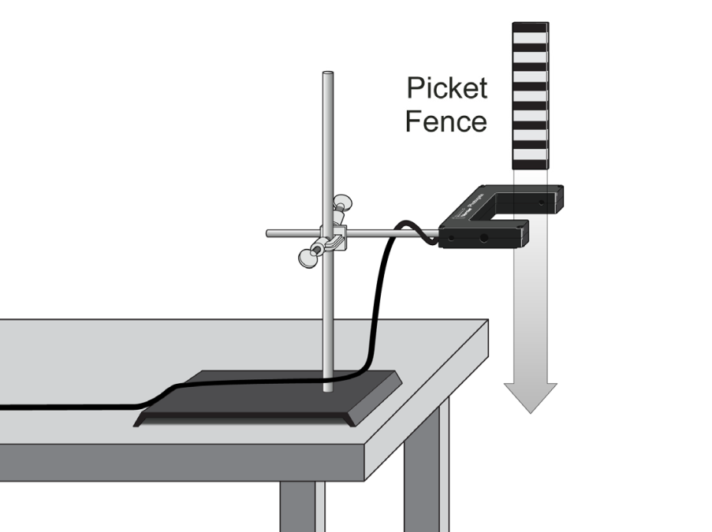
Fig 3.1: Showing Apparatus setup

Aim of the Experiment: To determine the acceleration due to gravity in the laboratory

Materials Required:

- Computer System with LabVIEW & MS Office Excel Installed
- Vernier Photogate with , Picket Fence, Force Plate
- NI myDAQ with Vernier myDAQ Adapter

Procedure for Hardware & Software Setup:

- Fasten the Photogate rigidly to a ring stand so the arms extend horizontally, as shown in figure. To avoid damaging the Picket Fence, provide a soft landing surface (such as carpet).
- Connect the Photogate to the digital (DIG) port of the Vernier myDAQ Adapter
- Make sure red light on the photogate blinks when you place obstacle in between.
- Open LabVIEW Project, and Open Program called as “ Measurement of g”
- Run the program, drop picket fence to pass through Photogate by placing it just 1-5 cm above first black fence.
- Once it passes vertically through photogate, the position versus time graph is displayed on the screen.
- Export the data to excel and plot a scattered chart
- Right click on the chart and click on add trend line>>select polynomial (2nd order) and click on add equation to chart
- Differentiate equation twice to get acceleration due to gravity
- Repeat the steps from e to i 5 times. Take the average value of g

Observation Table:

No. of Trials | Equation of motion ($y=At^{2}+Bt+y_{0}$) | Acceleration due to gravity $g=2A$ | Mean  $g$ (m/s²)
1
2
3
4
5

Conclusion:

The observed value of acceleration due to gravity in Physics lab, ITER, SOAU, Bhubaneswar is found to be ……….. The observed value is independent of the initial velocity of the picket fence during its motion through photogate.

Verification of Newton’s Second & Third Law

How does a cart change its motion when you push and pull on it? You might think that the harder you push on a cart, the faster it goes. Is the cart’s velocity related to the force you apply? Or, is the force related to something else? Also, what does the mass of the cart have to do with how the motion changes? We know that it takes a much harder push to get a heavy cart moving than a lighter one.
A Force Sensor and an Accelerometer will let you measure the force $\vec{F}$ and the acceleration $\vec{a}$ of the cart. Using the observed values Newton’s second law: $\vec{F}=m\vec{a}$ can be verified.

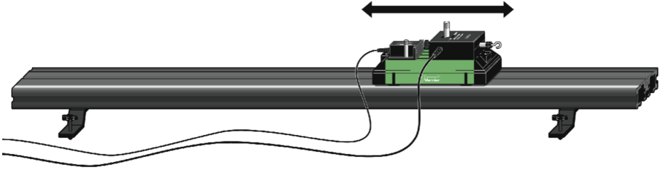
Fig 7.1: Vernier Track System Arranged for Newton’s Second Law

(A) Aim of the Experiment: To verify Newton’s second law of motion and determine unknown mass

Procedure for Hardware & Software Setup:

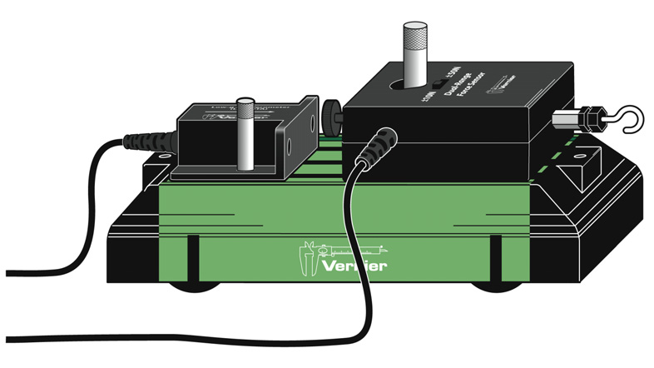
Fig 7.2: Vernier Cart with Sensors Placed

- Set the range switch on the Dual-Range Force Sensor to +/- 10 N.
- Attach the Force Sensor to a Dynamics Cart so you can apply a horizontal force to the hook, directed along the sensitive axis of the sensor
- Attach the Accelerometer so the arrow is horizontal and parallel to the direction that the cart will roll. Orient the arrow so that if you pull on the Force Sensor the cart will move in the direction of the arrow
- You can make use of available screw system to fix sensors on to cart.
- Setup the Sensors and Vernier myDAQ Adapter, Make sure you connect Low-g Accelerometer to Channel 1, Dual- Range Force Sensor to Channel 2.
- Also make sure whether myDAQ connected to LabVIEW properly
- Place the cart on Vernier Track system, run the program, Make sure the length of experiment is 30 s and Range of force sensor is set to +/- 10 N
- Run LabVIEW Program
- Grasp the Force Sensor hook. Click and move the cart up and down perpendicular to ground. Vary the motion so that both small and large forces are applied. Your hand must touch only the hook and not the sensors or cart body.
- Export the data to excel
- Chart the graphs
- Note down at least values of acceleration and force corresponding 10 different time instants.
- Calculate the ratio of the force and acceleration at each time instant
- Now remove low g accelerometer, attach additional mass onto the cart and again attach low g accelerometeras shown in the figure.
- Repeat steps e to m

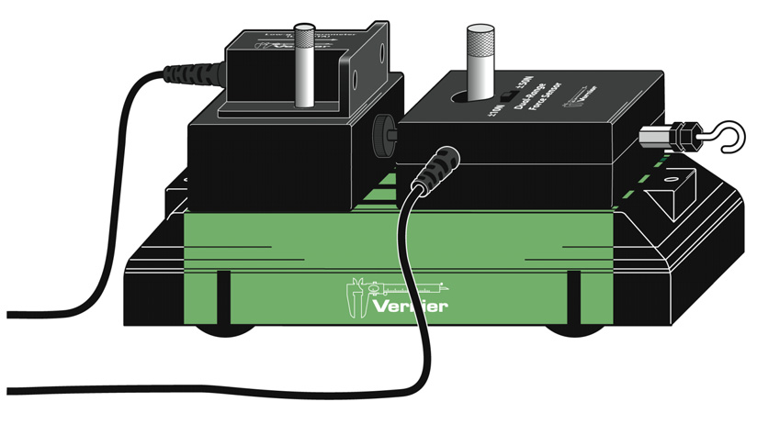
Fig 7.2: Vernier Cart with Sensors & Mass Placed
Observation Table:

No. of Obs. | Force applied on the cart |  |  |  | Force applied on the cart with added mass
No. of Obs. | Time  (s) | Accln. a  (m/s²) | Force F  (N) | F/a  (kg) | Time  (s) | Accln. a  (m/s²) | Force F  (N) | F/a  (kg)

Average F/a when force is applied on the cart = mass of the cart (M₁)=…..
Average F/a for the cart with added mass = mass of the cart plus mass added (M₂)=…..
Unknown mass added on the cart=M₂-M₁=…..

Newton’s Third Law:

You may have learned this statement of Newton’s third law: “To every action there is an equal and opposite reaction.” What does this sentence mean? This experiment will help you investigate this question and verify the law. Unlike Newton’s first two laws of motion, which concern only individual objects, the third law describes an interaction between two objects. For example, what if you pull on your partner’s hand with your hand? To study this interaction, you can use two Force Sensors. As one object (your hand) pushes or pulls on another object (your partner’s hand), the Force Sensors will record those pushes and pulls. They will be related in a very simple way as predicted by Newton’s third law.
The action referred to in the phrase above is the force applied by your hand, and the reaction is the force that is applied by your partner’s hand. Together, they are known as a force pair. This short experiment will show how these forces are related
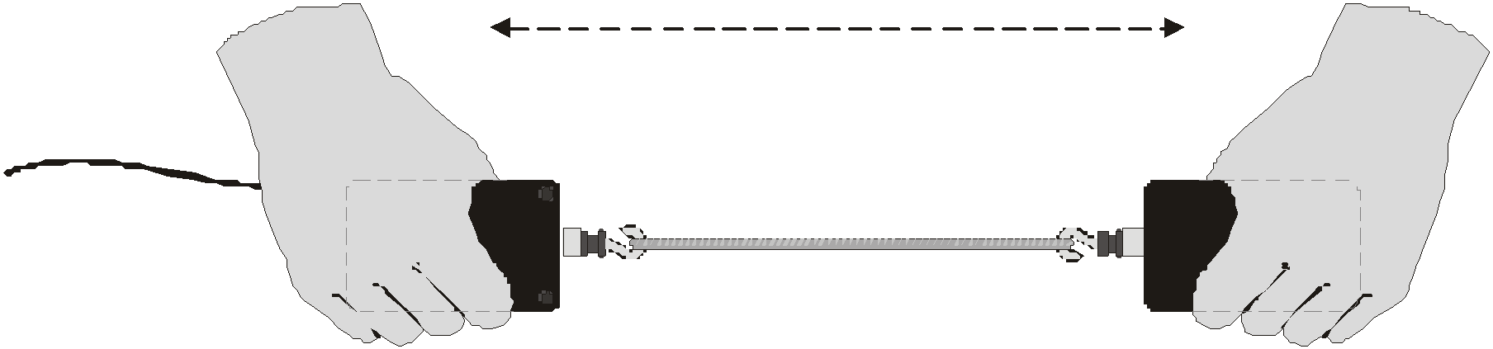

Fig 7.3: Two Force Sensors aligned

Aim of the Experiment: To verify Newton’s third law of motion

Procedure for Hardware and software setup:
- Set the range switch on the Dual-Range Force Sensor to +/- 50 N.
- Attach the Force Sensor to CH1 and CH2 of myDAQ
- Open LabVIEW Program Newtons Third Law
- Make sure range of Sensors in LabVIEW is also +/-50N & Length of experiment is about 30 s
- Pull out the sensors by connecting two hooks as shown in figure
- Observe change in force in two graphs on LabVIEW
- Export the data to excel
- Note down the values of force corresponding to 10 different time instants from CH1 and CH2
- Are you really able to get both readings from CH1 and CH2 same?
- Observe CH1 – CH2 = 0!

No. of Obs. | Force from Sensor_1  F₁₂ (N) | Force from Sensor_2  F₂₁ (N) | F₁₂ – F₂₁  (N)

Conclusion:
- Ratio of the force applied on a given object to its acceleration (F/a) is found to be constant which verifies Newton’s second law of motion. Using this relation the unknown mass added to the cart is found to be …….
- The difference of magnitude of action and reaction forces (F₁₂ and F₂₁) on two bodies is found to be vanishingly small which verifies the Newton’s third law of motion

Verification of principle of Conservation of Mechanical Energy

We can describe an oscillating mass in terms of its position, velocity, and acceleration as a function of time. We can also describe the system from an energy perspective. In this experiment, you will measure the position and velocity as a function of time for an oscillating mass and spring system, and from those data, plot the kinetic and potential energies of the system.

In vertical oscillations, the spring-mass system possesses energy three forms (kinetic energy (E_{k}), elastic potential energy (E_{p}) and gravitational potential energy). For mass m moving with velocity

$$E_{K}=\frac{1}{2}mv^{2}$$

The elastic potential energy of the spring stretched/compressed by y is
$$E_{P}=\frac{1}{2}ky^{2}$$
where, k is the spring constant given by $k=\frac{mg}{y}$ when the spring is stretched by y with a load mg

The mass and spring system also has gravitational potential energy , but we do not have to include the gravitational potential energy term if we measure the spring length from the hanging equilibrium position. We can then concentrate on the exchange of energy between kinetic energy and elastic potential energy.
If there are no other forces are acting on the system, then the principle of conservation of energy tells us that $E_{K}+E_{P}=constant$ which can be verified experimentally.
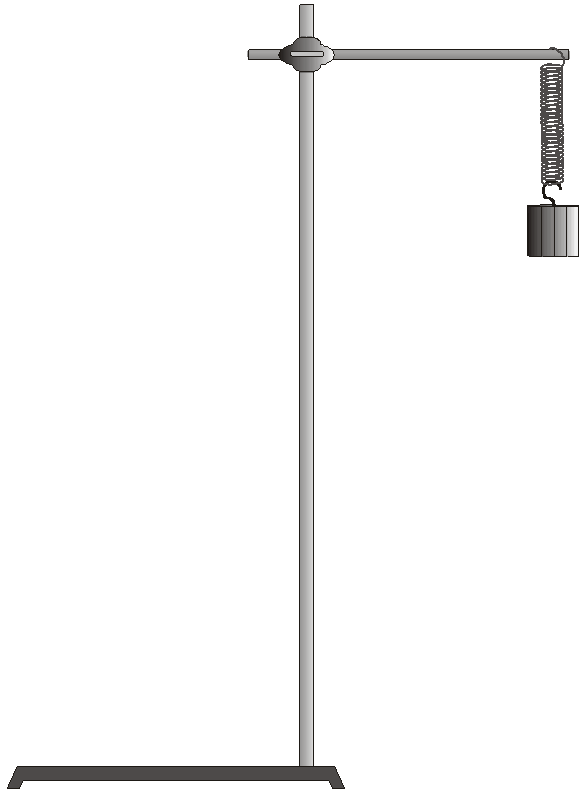

Fig 4.1: Apparatus for Conservation of Mechanical Energy

Aim of the Experiment: To verify the principle of conservation of mechanical energy for a vertically oscillating mass and spring system

Materials Required:

- Computer System with LabVIEW & MS Office Excel Installed
- Vernier Motion Detector
- Slotted Mass – 100 gms to 500 gms – 1 set
- Springs 15 N/m – twisted ties
- Physics retort stand or Ring stand
- NI myDAQ with Vernier myDAQ Adapter

Procedure for Hardware & Software Setup:

- Mount the 300 g mass and spring, as shown in Figure. Securely fasten the 300 g mass to the spring, and the spring to the rod, using twist ties so that mass cannot fall.
- Connect the Motion Detector to a digital (DIG) port of the interface. Set the Motion Detector sensitivity switch to Ball/Walk. And connect to Vernier myDAQ Adapter also
- Position the Motion Detector directly below the hanging mass, taking care that no extraneous objects could send reflections back to the detector. Protect the Motion Detector by placing a wire basket over the detector. The mass should be about 30 cm above the detector when it is at rest. Using amplitudes of 5 cm or less will then keep the mass at least 15 cm above the Motion Detector.
- Open Physics Lab LabVIEW Project and open Conservation of Mechanical Energy.
- Run program and find out distance between mass and motion detector which is nothing but zero calibration value.
- Enter Zero calibration value to make mean position of Motion sensor value to be zero, and enter values of k in N/m and mass in kg and move the mass upward maximum to 5 cm and leave the system to oscillate.
- Take care that the mass does not swing laterally.
- Click Run to record position and velocity data.
- View the graphs of E_{K} versus time, E_{P} versus time and total energy E, versus time on the screen
- View the graphs of E_{K} versus y, E_{P} versus y, E versus y
- Zoom position and velocity data corresponding to 3 consecutive oscillations by setting appropriate minimum and maximum values along time axis.
- Export the zoomed data to excel and plot a scattered chart. Note down at least 10 values of the position and velocity in equal time intervals during each cycle
- Calculate elastic potential energy and kinetic energy corresponding to observed position and velocity respectively
- Plot of E_{K} versus time, E_{P} versus time and total energy E, versus time on the graph sheet
- Plot the graphs of E_{K} versus y, E_{P} versus y, E versus y on the graph sheet

Observation Table:

No. of obs. | Time, t  (s) | Position, y (m) | Velocity, v (m/s) | E_{K}  (J) | E_{P}  (J) | E  (J)
1
2
3
.
.
.
.
30
Conclusion:

During the vertical oscillation of the spring the sum total of kinetic and elastic potential energy of the mass and spring system remains almost constant. The small decrease in the total energy is due to the damping factors affecting the simple harmonic motion of the system.

